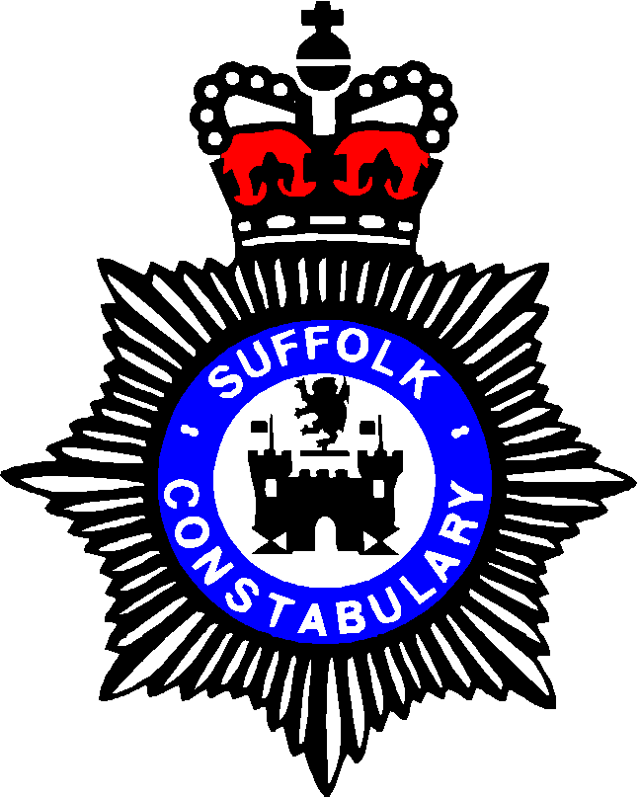
WOODBRIDGE AND DISTRICT
SAFER NEIGHBOURHOOD TEAM

Police station, Grundisburgh Road, Woodbridge

CLOPTON PARISH COUNCIL POLICE REPORT

Date 30/01/2014

CRIME UPDATE

There have been no reported crimes since your last meeting on 21/11/2013:

HOW DOES THIS COMPARE WITH OTHER PARISHES IN THE WOODBRIDGE AND DISTRICT SNT AREA DURING THE SAME TIME PERIOD (21/11/2013 – 29/01/2014)

BAWDSEY 1
BOYTON 1
BROMESWELL 2
BUTLEY 1
CAMPSEA ASHE 1
DALLINGHOO 1
EYKE 2
HASKETON 4
HOLLESLEY 7
MELTON 8
ORFORD 1
OTLEY 4
RENDLESHAM 11
SHOTTISHAM 1
SUDBOURNE 1
SUTTON 5
TUNSTALL 2
UFFORD 2
WANTISDEN 2
WICKHAM MARKET 7
WOODBRIDGE 42

SNT CURRENT PRIORITIES

The last Community Panel Meeting was held on 21/08/2013. The three priorities set by the general public were as follows;

Priority 1: To increase road safety by reducing speeding through UFFORD village on the
B1438. IP13

Priority 2: To tackle anti-social behaviour, including vehicle nuisance, in RENDLESHAM
Village, particularly around Costcutters car park and surrounding roads. IP12

Priority 3: To tackle anti-social behaviour, including vehicle nuisance, in WICKHAM
MARKET, particularly around Market Hill and football club play areas. IP13

The next Priority Setting Meeting will be held at RENDLESHAM COMMUNITY CENTRE on Wednesday 20th November 2013 at 7pm

SPEEDING

If there are any areas that you feel need attention during our speed enforcement days, then please let us know.

LOCAL ANTI SOCIAL BEHAVIOUR ISSUES (ASB)

There have been no recorded reports of anti social behaviour in Clopton that I am aware of since your last meeting.

MOBILE POLICE STATION

The date for the next visit is Thursday 20th March, 1000-1035 hrs at Rouse Hall Estate

OTHER MATTERS

Police Direct

For those of you that haven’t signed up for Police Direct yet, please don’t forget about it! The service is free, easy to use and is proving to be a very valuable policing tool.
The service doesn’t just assist us it also benefits you. You will receive regular updates either via text, email or landline letting you know what is happening in your area.
Leaflets are available at all police stations or visit our website.

CONTACTING THE POLICE

YOUR LOCAL OFFICERS ARE:

PC 1469 Debbie Howgego

PCSO 3094 Sallyanna Chatten-Berry

In an emergency always dial 999

To report a crime, speak to your local officers or leave a message please dial 101

Any member of the team can be contacted at woodbridge.snt@suffolk.pnn.police.uk

Check the website www.suffolk.police.uk for our engagements

Our website as detailed below also has an email link to contact us.

Please also have a look at the Suffolk Constabulary Website, which can offer further help and advice.

To find the Woodbridge and District Team website please see www.safersuffolk.org.uk

Kind regards,

Debbie Howgego
PC 1469

